

HPC Credit Union

Business Online Banking Instruction Manual

Table of Contents

Welcome…………………………………………………………………………………………3
Logging into Business Online Banking…………………………………………………………4
Accessing PIB MLO…………………………………………………………………………….6
Creating Users for Business Online Banking in PIB MLO……………………………………..9
Using PIB MLO……………………………………………………………………………….. 11
Additional Business Online Banking Permissions Using PIB MLO………………………….. 14
Resetting Business Online Banking Passwords in PIB MLO…………………………………. 16
Resetting PIB MLO Password………………………………………………………………… 18
Reset of Administrators Own Password using PIB MLO………………………………………20

Welcome
Welcome to Business Online Banking (also referred to as BizLink 247) and Personal Internet Branch Multi-User Login (PIB MLO)! Designed for the special needs of our business members, Business Online Banking and PIB MLO allows a business owner to have separate logins for each employee, with each employee having individual permissions in online banking.

What is PIB MLO?
PIB MLO is the online security tool that business owners can use to have complete control over access to their Business Online Banking accounts. Using PIB MLO, business members can add users and define their permissions. They can also use this tool to reset secondary user passwords for Business Online Banking.

Online Business Banking Team- HPC Credit Union Staff

Katie Yachcik: Membership Officer
(989) 340-2710
Natalie Jaskolski: Membership Officer
(989) 340-1920

Logging into Business Online Banking
Business Online Banking can be accessed through HPC Credit Union’s website at www.hpccu.com and selecting the Online Banking button in the upper right corner and then selecting the Business Teams.
You will enter the Company ID and Employee ID provided to you when your business account was first opened, followed by entering the temporary password that was emailed to you. If you have forgotten or misplaced your login credentials, contact us at (989) 354-4698.
You will receive two emails containing temporary passwords: one for Business Online Banking (BizLink247) and another for PIB MLO. Make sure that you enter the temporary password for Business Online Banking and not PIB MLO. After entering the temporary password, you will provide a permanent password and create three security questions and answers.

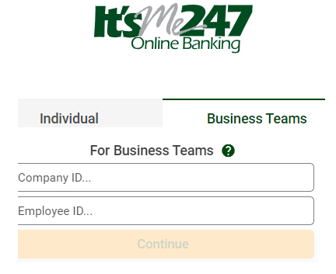

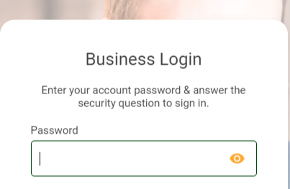

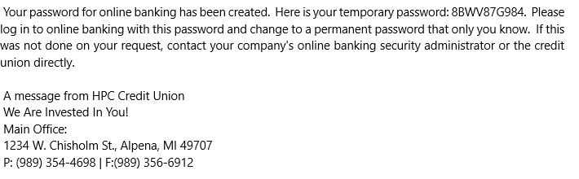

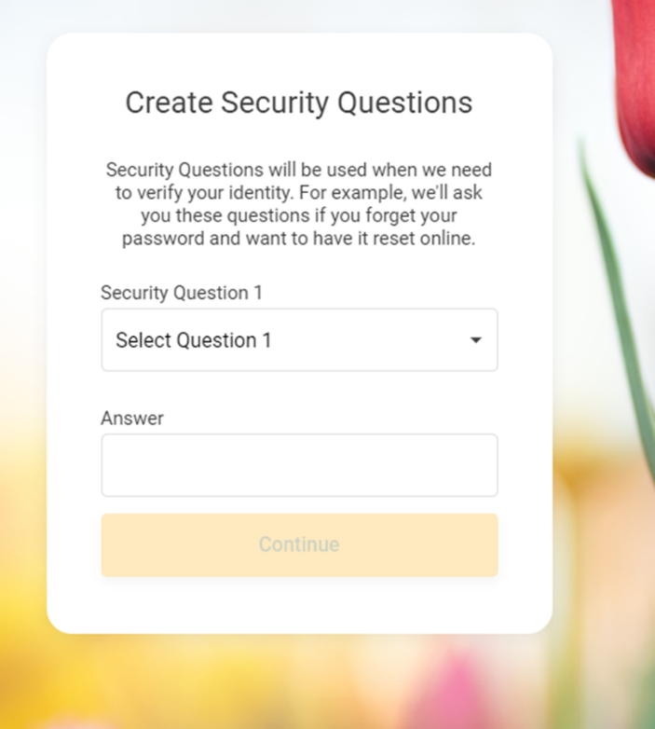
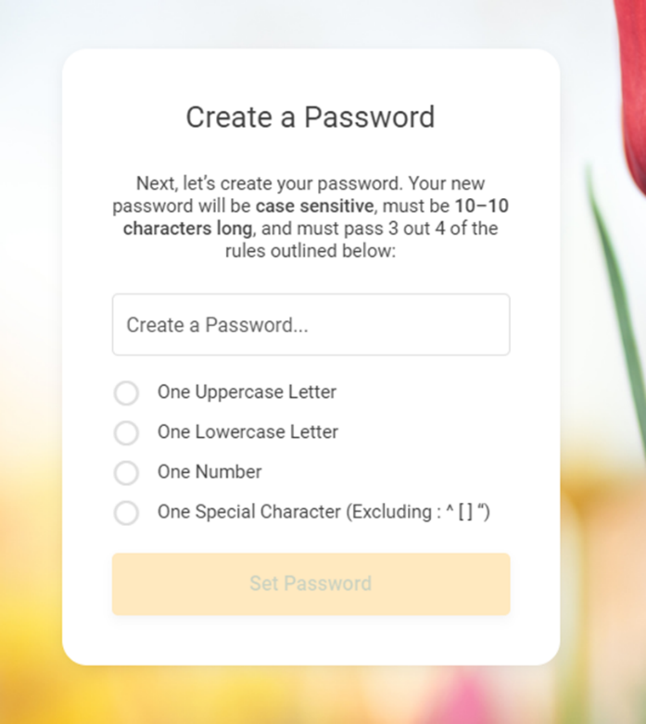

Accessing PIB MLO
PIB MLO can be accessed by clicking the Manage My Security link at the top of the page in Business Online Banking. This Manage My Security link is available only to users who have PIB MLO access and are administrative users.
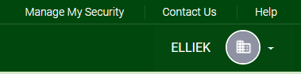
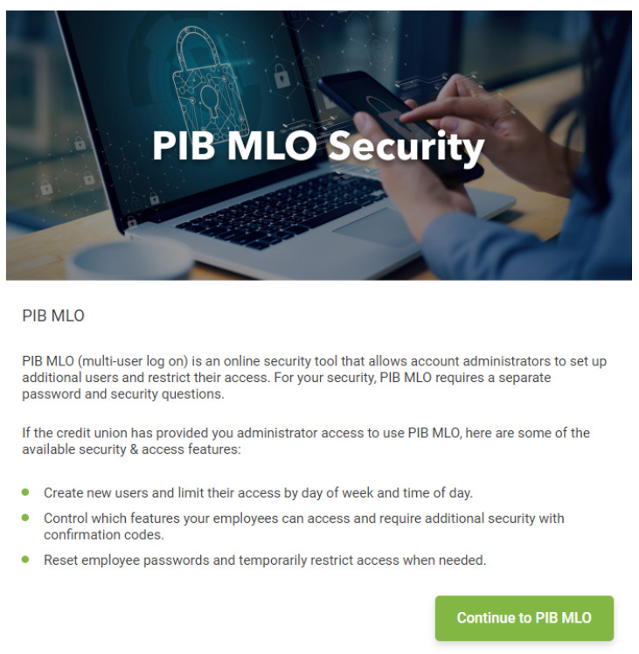

The administrator will enter the Company ID and Employee ID used for Business Online Banking to access PIB MLO.
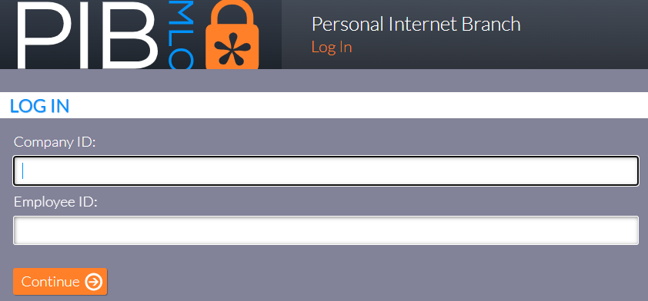
The administrator will enter the temporary password that was provided in the PIB MLO welcome email issued by the credit union upon account setup.
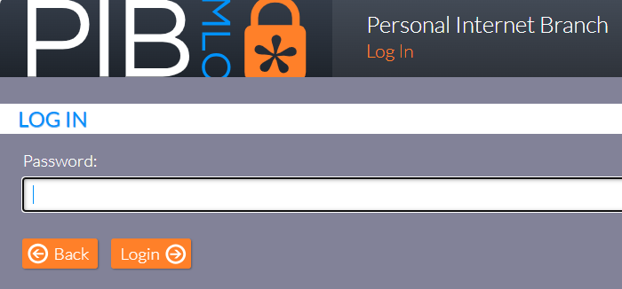
A permanent password will need to be set up for any users who are accessing PIB MLO for the first time. Please note, the current password is the temporary password entered in the next step.
Passwords must be between 6 and 10 characters in length, and must contain at least one uppercase letter, one lower-case letter, one number, and one special character.

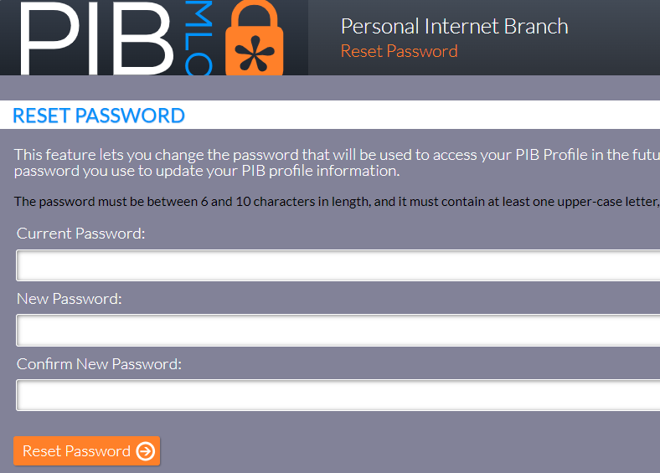
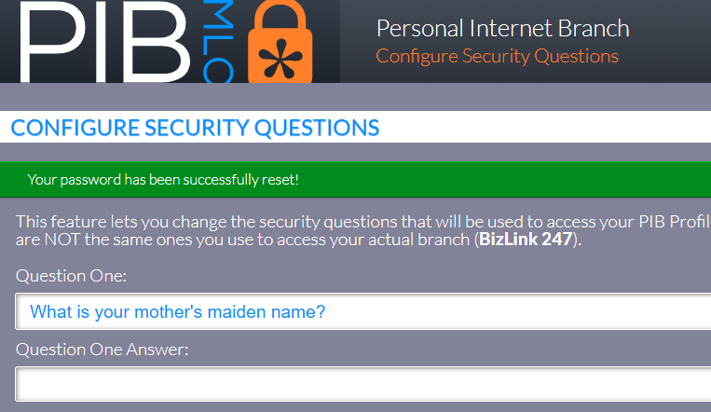
After completing the permanent password reset, the administrator will be required to create three challenge questions and answers, similar to those for Business Online Banking.
Creating Users for Business Online Banking in PIB MLO
To add a new profile(s) in PIB MLO, an administrator will select Create New Profile.
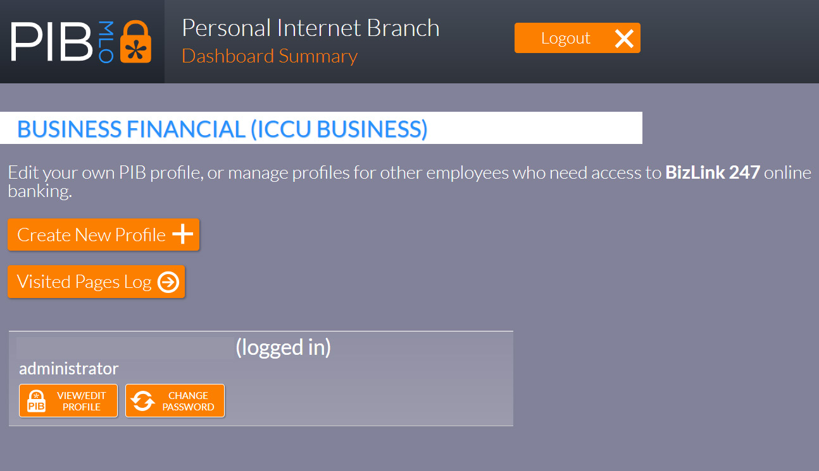
The administrator will then be prompted to create an Employee ID, enter the employees email address, and select the authority level of the user.
There are three PIB MLO security levels:
1. Full Administrator – This user has access to Business Online Banking and PIB MLO.
2. Reset Passwords – This user has access to reset passwords in PIB MLO.
3. BizLink 247 Access Only – This user does not have access to PIB MLO.
Generally, you will select BizLink 247 Access Only, unless you are creating another PIB MLO administrator or want to entrust another employee to be able to reset passwords.
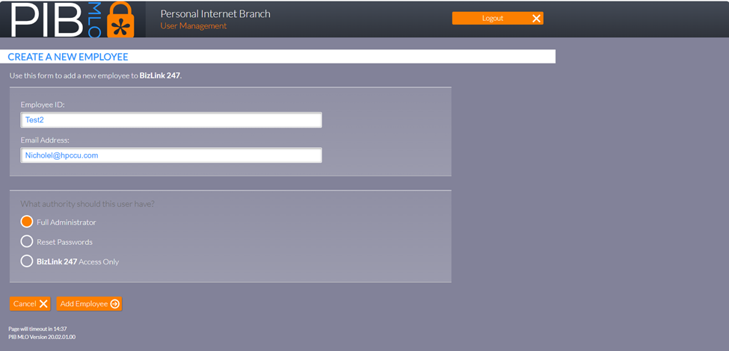
Once all the information has been entered, the administrator will select Add Employee to complete the addition of the new user.

When an administrator adds a user, an email will be generated and sent to the new user with their temporary password. All temporary passwords (initial or reset) expire after 24 hours. At that point, the password will need to be reset with a permanent one upon logging in.

An authorized representative of the business will need to ensure that each user is also given the Company ID and the Employee ID (assigned to each user). All three items (Company ID, Employee ID, and password) will be needed to login. This will need to be coordinated with the assigning of permissions to each user.

Using PIB MLO
To access Business Online Banking, each user must have a profile setup in PIB MLO.
The individual permissions for each user are assigned by their profile. When a profile is set up via PIB MLO, all permissions and access levels are set to off, or no, by default.
Once the user is added, the administrator will see the user management menu (as shown below). Each user profile can be customized with the following permissions:
Login & Device Management: grant permissions for the days and times a user can have access to Business Online Banking, and from which device(s) the user can access online banking.
Money Management: grant access to cash management for the organization, such as transferring funds between accounts, managing ACH transactions, placing stop payment orders, and more.
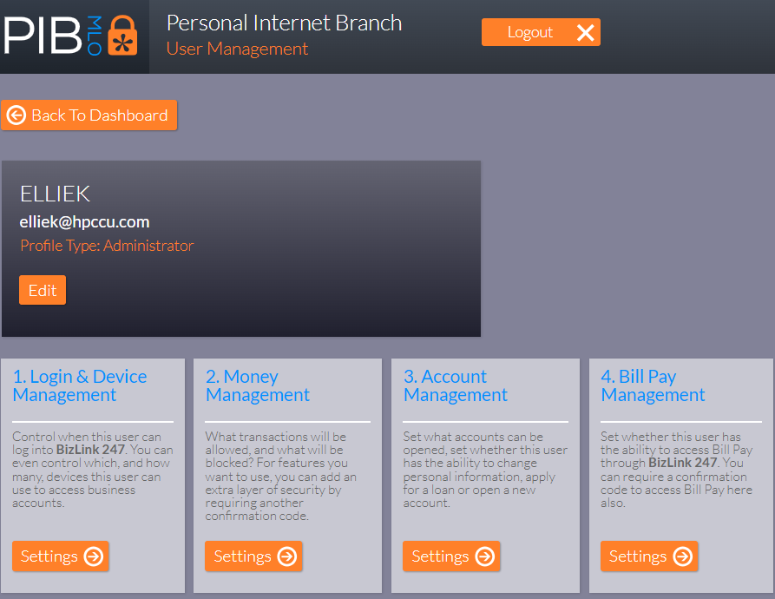
Account Management: grants access to activities affecting the entire membership, such as opening new savings and checking accounts, viewing eStatements, and responding to messages posted in the message center.

A user added via PIB MLO must be granted access to BizLink 247 (days and times allowed). To do this, the administrator will select the Settings button under Login and Device Management.

The screen will default to Limit Access by Day of Week. No days are selected by default.

To grant a user access to Business Online Banking, select the applicable day(s) the organization wants to grant online banking access to the user.
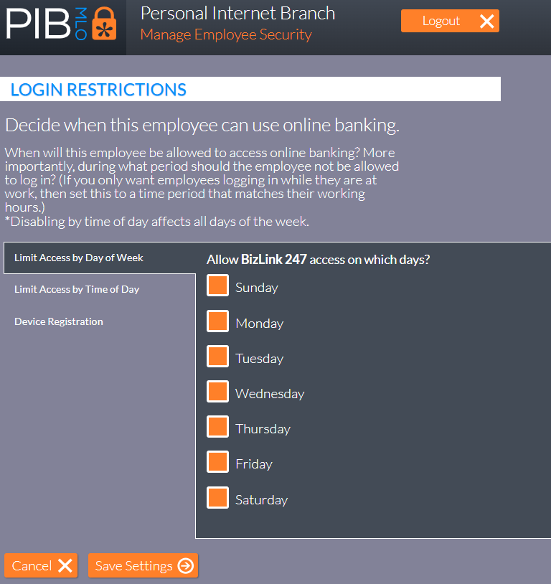
Next the administrator must indicate which hours of the day the user can access online banking.

To do this, select Limit Access by Time of Day and choose from the following options:

• Early Morning: 12:00am – 4:59am
• Morning: 5:00am – 11:50am
• Afternoon: 12:00pm – 7:59pm
• Evening: 8:00pm – 11:59pm

Note: time zones can also be selected to coincide with the location of each user or the business.

Select Save Settings to complete the Login and Device Management changes to the user profile.

Device Registration allows an administrator to restrict access to online banking to specific access devices (i.e., company computers) if desired.

Additional Business Online Banking Permissions Using PIB MLO
The Money Management menu will allow PIB MLO administrators to enable and limit access to cash management tools for specific users within the organization.

Users can be restricted to the following money management controls:

• Account Transfers
• Automatic Fund Transfers
• Automated Clearing House (ACH) Deposits
• Check Withdrawals (Credit Union Cashier Checks)
• Viewing Cleared Checks
• Stop Check Payments
• Overdraft Services
• Order Checks
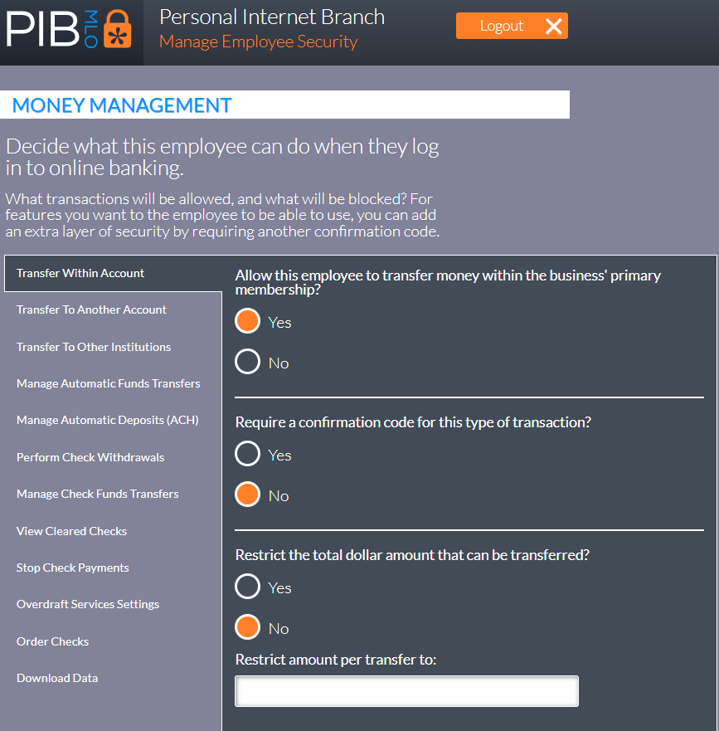
• Download Account History

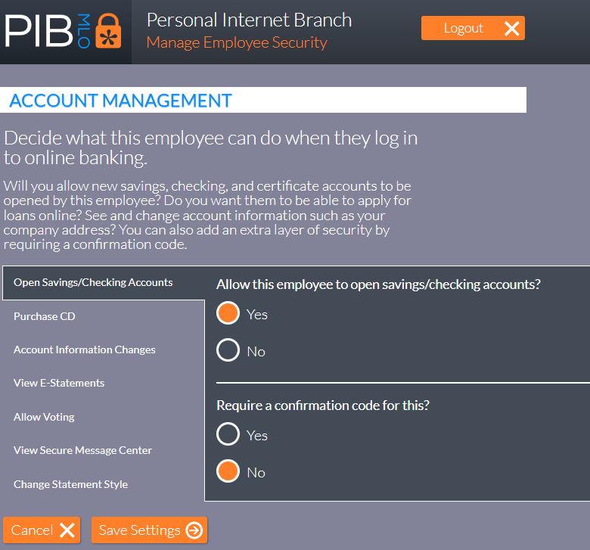
The Account Management menu will allow PIB MLO administrators to enable and limit users to open new products and services within online banking.
Users can be restricted to the following account management controls:
• Open Sub-Accounts
• Purchase CD’s (Certificate of Deposit)
• Account Information Changes
• View eStatements – if applicable
• Allow Voting
• View Secure Message Center
• Change Statement Styles

Resetting Business Online Banking Passwords in PIB MLO
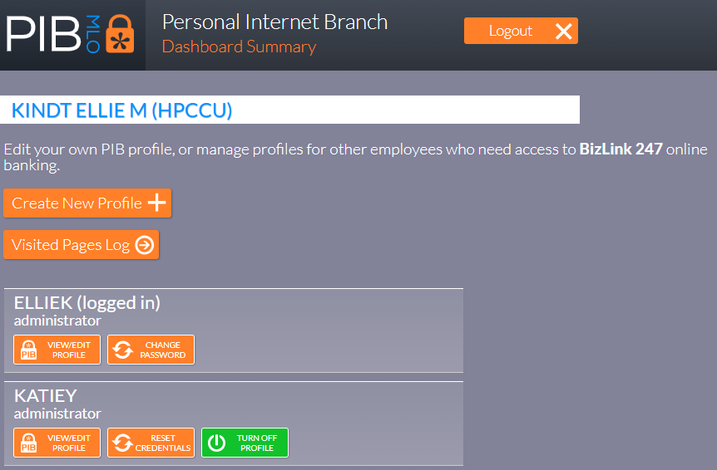
To reset a user’s password, an administrator will log into PIB MLO and select the Reset Credentials option on the user’s profile.

If the user whose credentials are being reset also has access to PIB MLO, the option to reset either the user’s PIB MLO or BizLink 247 credentials will be shown. Otherwise, BizLink 247 will only be shown.
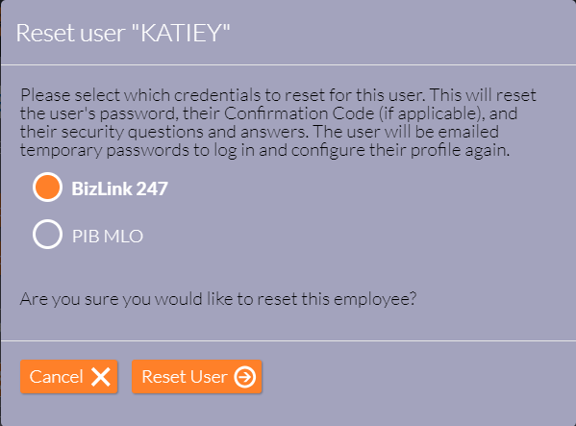

Select Reset User to complete the password and profile reset.

The user’s profile will be reset, and a temporary password will be sent to the user’s email address associated with their profile.

All temporary passwords will expire after 24 hours. When the user logs into online banking, they will be required to change their password.

Resetting PIB MLO Password
There are three ways that PIB MLO passwords can be reset.

1. Through the login screen using the I forgot my password link (shown below).
2. PIB MLO Administrators can reset another PIB MLO user’s credentials.
3. Assistance from a credit union employee.

To change a PIB MLO password, administrators or credentialed administrators select the I forgot my password link on the second PIB MLO login screen, shown below, after entering the Company ID and Employee ID on the first screen.
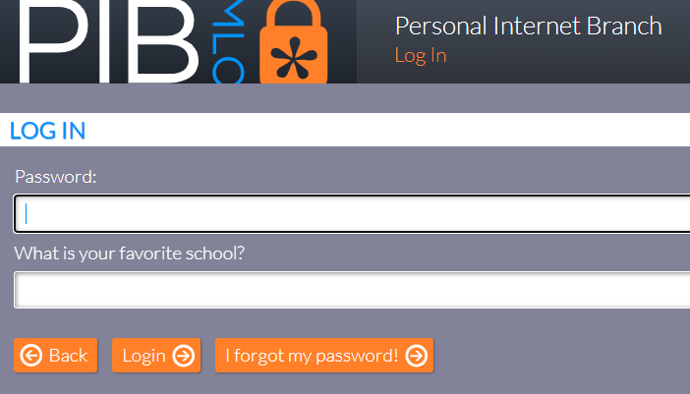
The PIB MLO administrator will need to correctly answer all three security questions before the user’s credentials are reset.
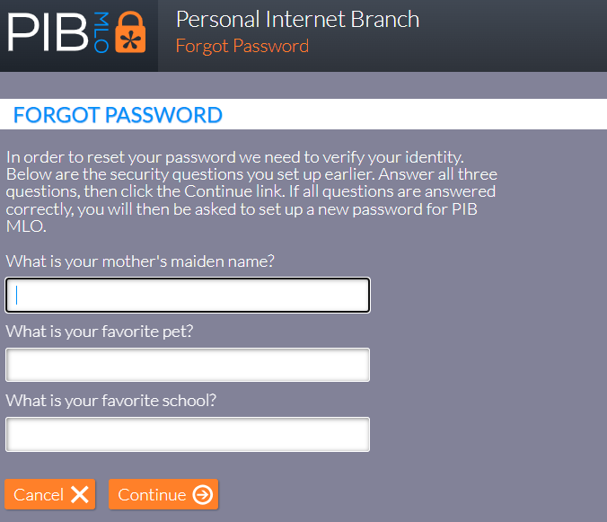

Reset of Administrator’s Own Password using PIB MLO
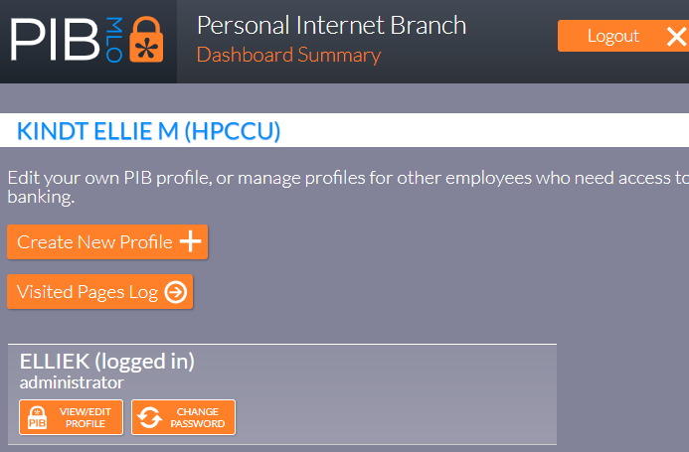
If an administrator can successfully log into PIB MLO, they can reset their own password through the Change Password link (shown below).

The PIB MLO administrator will enter their current password, new password, and confirm their new password before selecting Reset Password to complete the PIB MLO password reset.
