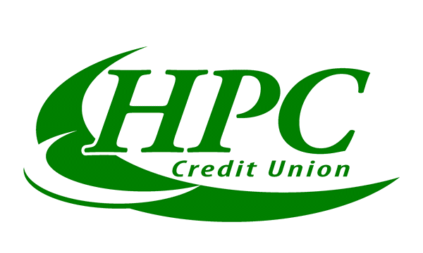
1234 W. Chisholm Street  Alpena, MI 49707
Phone: (989) 354-4698  Fax: (989) 356-6912  Toll Free: (888) 554-5944

Memo

Date:
Subject: | Direct Deposit

This is to verify that the following account can accept direct deposits.

Account #:
Routing #: 272476462
Name:
Please feel free to contact us at the above numbers with any questions.

Sincerely,
HPC Credit Union
MSR

